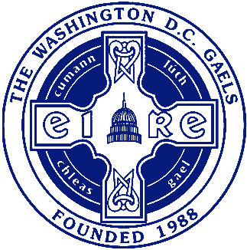
The Washington DC Gaels GAA
AGM Documents | dcgaels.com

2020 AGM: Motions

(If possible, please list the By-Law, Rule, or Regulation that is being changed or affected by the proposed motion)

Motion #1:

Motion #2:

Motion #3:

Please return via email to secretary@dcgaels.com
by Sunday, 22nd November 2020

